NST21022 - Practical for Network Routing and Switching
Department of Information and Communication Technology
Faculty of Technology
Lab sheet : 01
Reg. Number: SEU/IS/20/ICT/084
Academic Year :2020/2021
Practical No :01

Title:
- Introduction to Packet Tracer, Putty and CISCO IOS
Aims:
  - Getting familiar with Cisco Packet Tracer
  - Identify the common components of a Network
  - Getting the basics on Cisco IOS
  - Getting familiar with connections (cables)
  - Getting familiar with basic nodes (devices) configuration

Tasks:
  - Download and Install Cisco Packet Tracer
  - Identify the common network components in Packet Tracer
  - Install nodes in the Packet Tracer Workspace
  - Practice with node’s properties
  - Create a simple network
  - Get access on nodes
  - Try Cisco IOS basic commands
  - Create a simple network
  - Create a simple network with switch
  - Connect multiple devices with switch

Activities

- Download and install Cisco Packet Tracer
- Getting familiar with common network components
  - Network devices
  - End devices
  - Connections
- Select PC from end devices tab and install it on workspace
- Double click the PC and find out the properties and settings
- Select Router from Network devices tab and install it on workspace
- Double click the Router and find out the properties and settings
- Click the router and get into config tab and go to the CLI tab and try following
- commands
  - show version
  - show terminal
  - show ssh
  - show clock
- Navigate to router configuration mode
  - enable
  - configure terminal

Exercises 1.

01.
- Create a simple network between 2 PCs with suitable connections

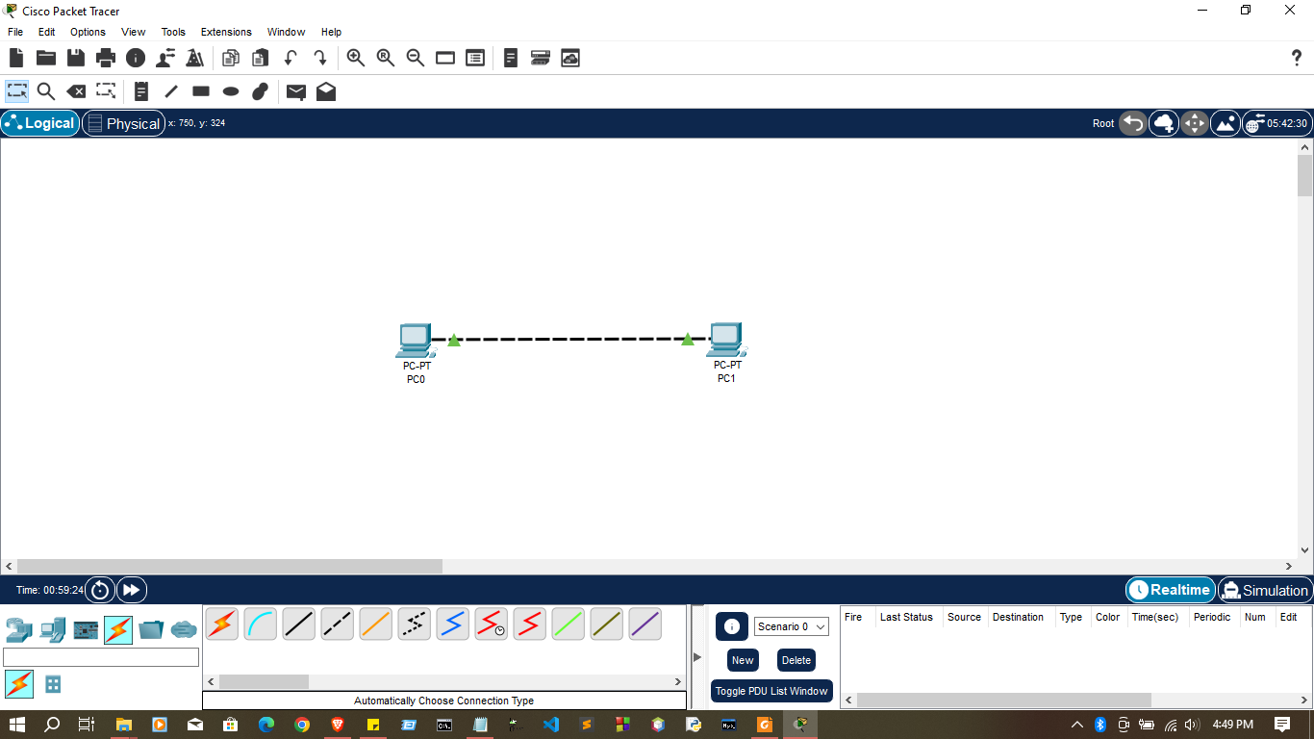

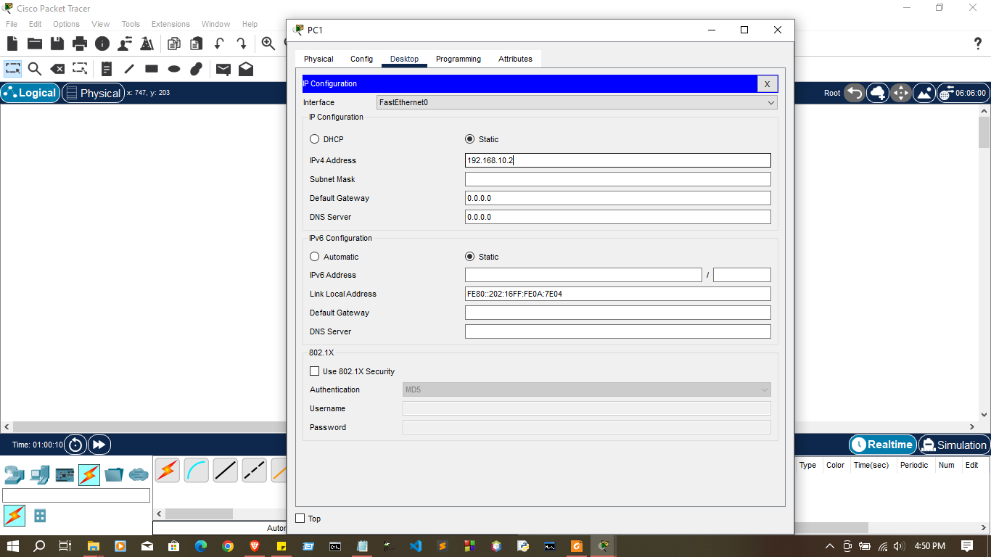
- Configure IP address to PCs

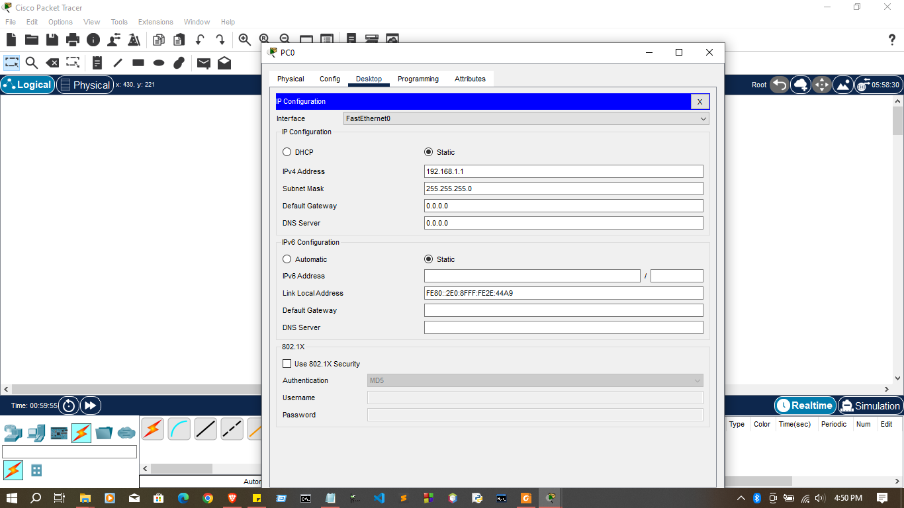
- Check connection between PCs
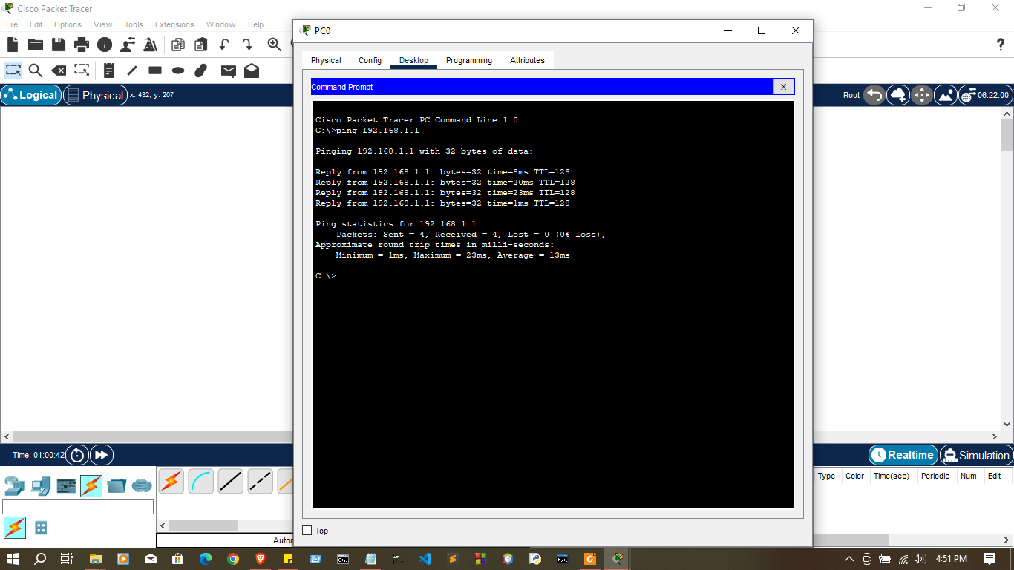

- Try to check connection using simulation mode 2.
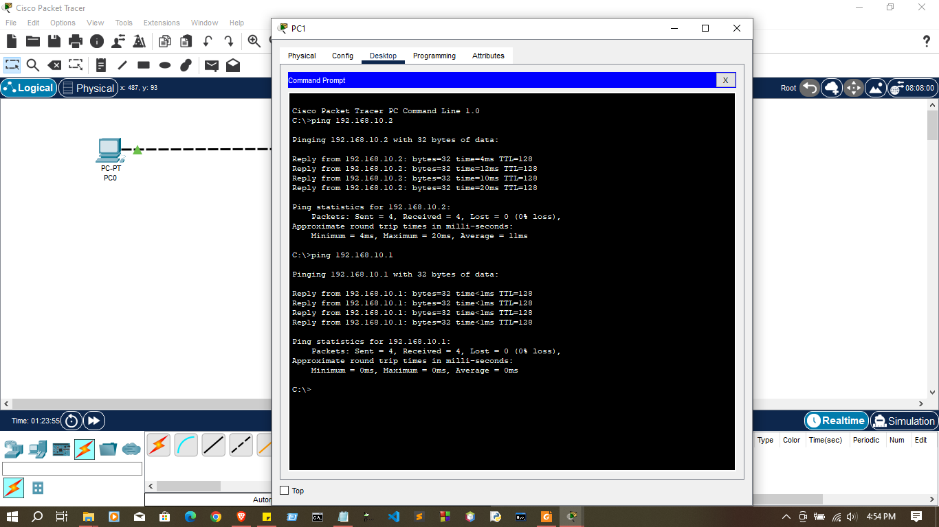
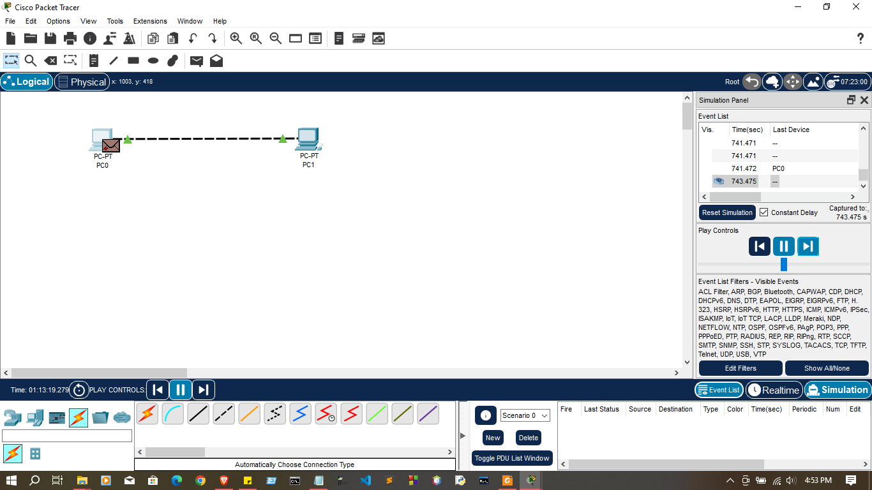

02.
- Create a simple network between 2 PCs with a switch

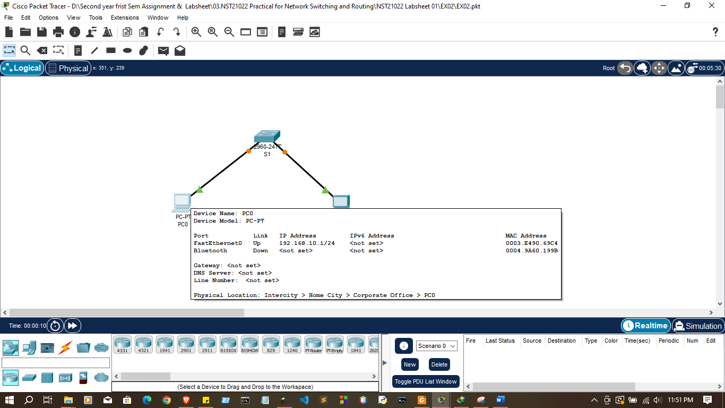

- Configure IP address to PCs

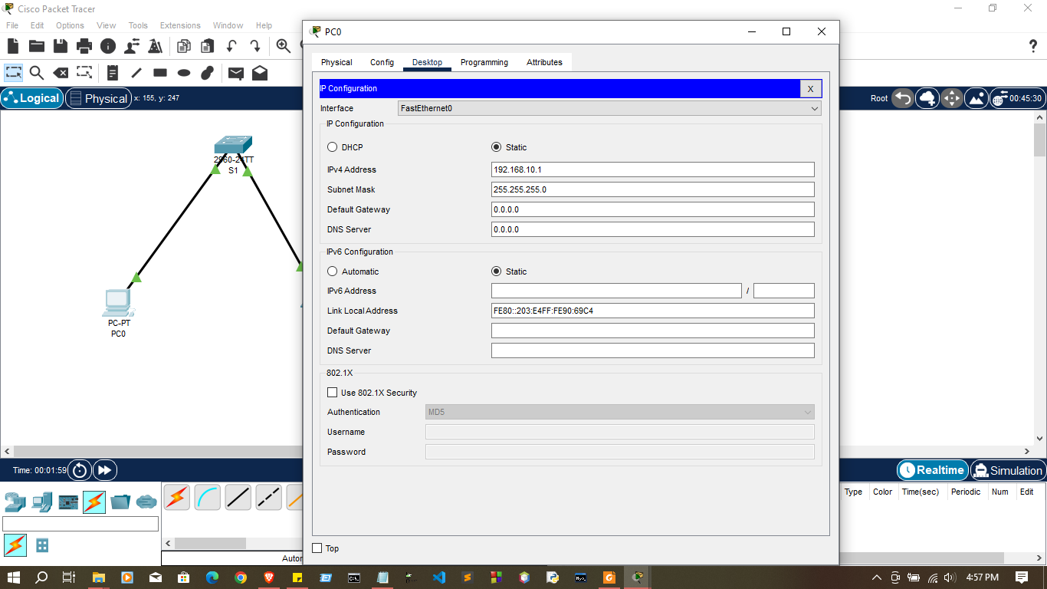
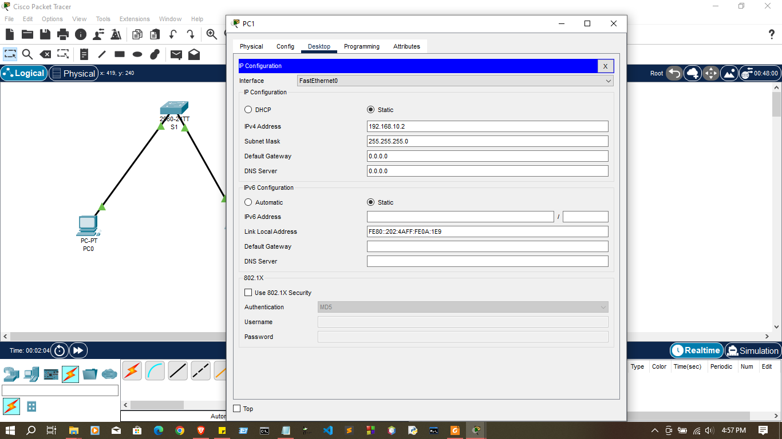

- Check connection between PCs

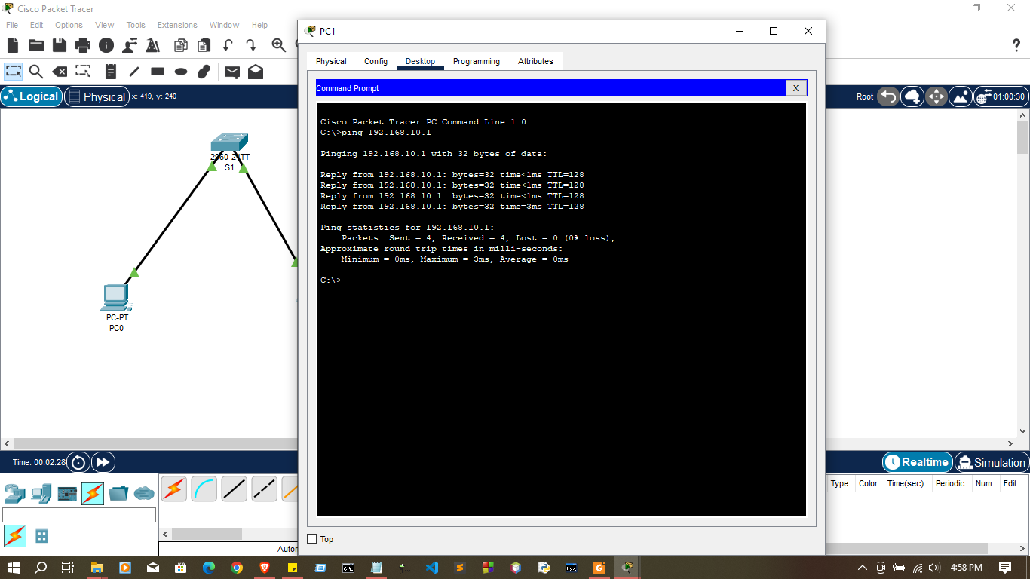

- Try to check connection using simulation mode

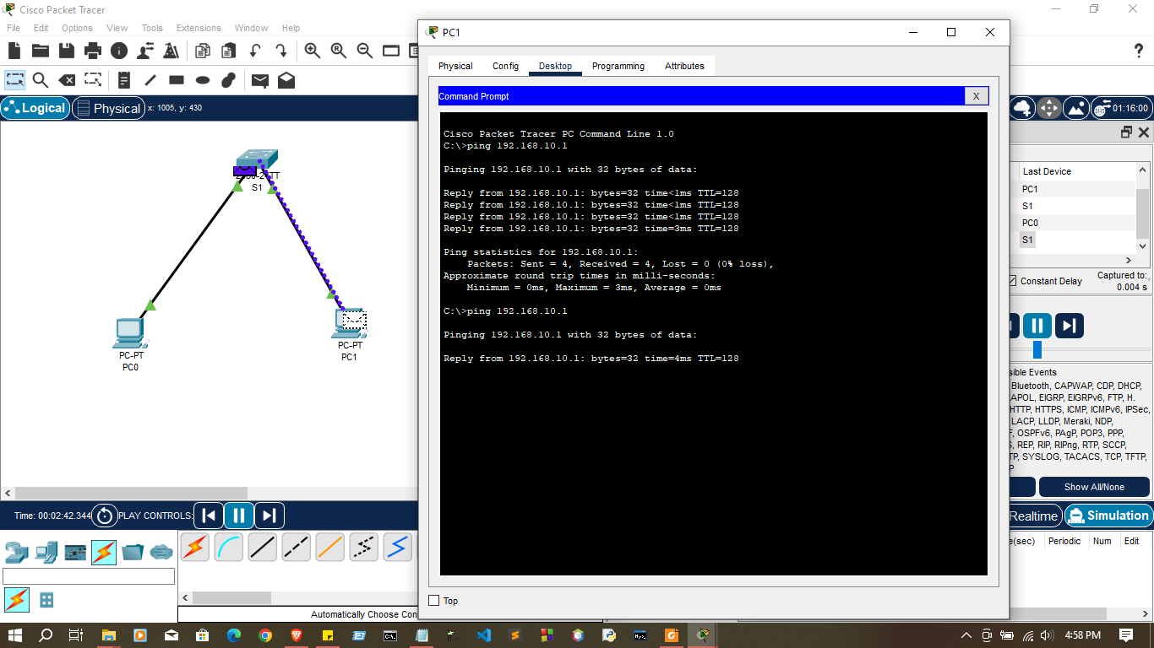

Discussion:
- To day we discussion Important topics about the use of Cisco Packet Tracer for network simulation and education were discussed. The first step in the procedure is to download and install the Cisco Networking Academy software. After installation, users can use the Packet Tracer workspace to recognize and make use of typical network components like switches, routers, and end devices.

- The talk focused on the doable procedures for setting up nodes in the workspace, experimenting with node attributes, and building a basic network. Users gained knowledge of how to use the command-line interface (CLI) to access nodes, examine their properties, and carry out fundamental Cisco IOS operations.
- The addition of switches and the resulting increase in network complexity were also discussed. It was suggested that users set up a basic switch network and link several devices to it in order to simulate a local area network.

Thank you..

